PSG COLLEGE OF TECHNOLOGY, COIMBATORE – 641 004
DEPARTMENT OF COMPUTER APPLICATIONS
AY 2026-2027 MCA First Year Semester 1
26MX17 WEB APPLICATION DEVELOPMENT
Design Abstract
I. Team Detail
Batch No. | Roll No. | Name of the student | Name of the Faculty Guide
26MX | 26MX325 | KIRUBHAKARAN K | DR. ILAYARAJA N
26MX | 26MX337 | POOJA M | DR. ILAYARAJA N
26MX | 26MX347 | SRINITHISH J K | DR. ILAYARAJA N
II. Title of the Application
TrustVault - Smart Digital Identity and Document Verification Portal for college students and faculty.
III. Abstract
TrustVault is a secure web application in which MCA students keep their identity and academic documents (PAN, Aadhaar, driving licence, marksheets and certificates) in one encrypted vault and share them with faculty only with their consent. Unlike general cloud storage such as Google Drive, every file is encrypted with AES-256-GCM, sign-in needs three factors (password, an email code and Google Authenticator) and a separate PIN protects the vault. Each upload is checked automatically (format, Aadhaar checksum, OCR and signs of editing) and is verified only when every check passes. Faculty request documents from one student or a whole batch such as 26MX, each shared document opens only once, and every upload and decision is sealed in a SHA-256 hash-chained ledger. Built with React, Node.js, Express and MongoDB, the application makes document verification faster, safer and transparent for the department.
IV. Existing System (Indian & Global)
- DigiLocker (India)
DigiLocker is the digital document wallet of the Ministry of Electronics and Information Technology, Government of India, under the Digital India programme. Citizens store and share government-issued documents such as Aadhaar, PAN, driving licence and board marksheets, which are fetched directly from the issuing departments.
- National Academic Depository - NAD (India)
The National Academic Depository is an online store of academic awards such as degree certificates and marksheets, lodged by universities and boards and offered through DigiLocker, so that students, employers and institutions can access and verify them online.
- Google Drive (Global)
Google Drive is a cloud storage service in which users keep files of any kind and share them through links or with chosen people. It is widely used by students to send scanned certificates, but it does not check whether an uploaded document is genuine.
- Parchment (Global)
Parchment is a credential platform used by schools and universities, mainly in the United States, to issue and send official digital transcripts, diplomas and certificates that receiving institutions and employers can verify.
V. Proposed System
The proposed system, TrustVault, is a secure, college-exclusive web application in which MCA students store their identity and academic documents and share them with faculty only with consent. Sign-up is limited to valid MX roll numbers for students and to department codes or email invitations for staff, and every sign-in passes three steps: password, an email code and Google Authenticator. Uploaded files are encrypted with AES-256-GCM and checked automatically (PAN format, Aadhaar Verhoeff checksum, driving licence format, OCR and originality traces); a document is verified only when every check passes, otherwise the student sees which check failed. Faculty request documents from one student or a whole batch, the student shares all, some or none, and each shared document opens once within 24 hours. The administrator manages users and reviews the audit log but cannot open students' files, making TrustVault a trusted, transparent and paperless verification system for the department.
VI. Objectives of the Proposed Application
- To develop a secure, college-exclusive document vault for MCA students.
- To protect every document with AES-256-GCM encryption and a vault PIN.
- To allow access only through three-factor sign-in (password, email code, TOTP).
- To verify documents automatically using format rules, checksums and OCR.
- To let faculty request documents from a student or a batch, with consent.
- To allow each shared document to be opened only once, within 24 hours.
- To keep a tamper-evident record of every action in a hash-chained ledger.
- To reduce paperwork and manual verification in the department.
- To build a responsive web application that also installs on Android phones.
VII. Scope / Use
Target Environment
Designed for the Department of Computer Applications (MCA students, faculty and office staff), adaptable to other departments and colleges.
Secure Digital Vault
Keeps identity documents (PAN, Aadhaar, licence) and academic records (marksheets, certificates) in one encrypted place.
Automatic Verification
Checks documents in seconds without a manual verifier and tells students what to fix.
Consent-Based Sharing
Faculty receive documents for placements, scholarships and records only when the student agrees.
Transparency & Privacy
An audit log and a tamper-evident ledger record every action; consent and account deletion follow the DPDP Act 2023, with future expansion to employers.
VIII. Technology to be used (Specific Framework etc.)
- Frontend: React 19 with Vite, Tailwind CSS and shadcn/ui (responsive web interface).
- Backend: Node.js with Express 5 (REST API).
- Database: MongoDB with Mongoose (users, documents, requests, ledger and audit log).
- Authentication: Password (bcrypt), email OTP, Google Authenticator (TOTP), JWT.
- Security: AES-256-GCM encryption, SHA-256 ledger, Helmet, rate limiting.
- Document checks: Tesseract.js OCR, Sharp and pdf-lib for images and PDFs.
- Deployment: Render (cloud hosting), GitHub Actions (CI/CD), Capacitor (Android app).
IX. Functional Requirements of the Application
User Registration & Authentication
- Students register with a valid MX roll number; staff join with a code or invitation.
- Sign-in needs password, email code and Google Authenticator.
Document Vault Management
- Students upload, view and delete documents in Identity, Academic and Other.
- Files are encrypted, numbers are masked and a PIN unlocks the vault.
Automatic Document Verification
- Format, checksum, OCR and originality checks give a score out of 100.
- Verified only when every check passes; failed checks are shown.
Faculty Requests & Consent
- Faculty request documents from one student or a whole batch (e.g. 26MX).
- Students share all, some or none; each document opens once in 24 hours.
Administration & Audit
- The administrator manages users, roles and invitations and the audit log.
- A ledger integrity check detects any changed file or record.
Notifications & Export
- Email alerts for new devices, requests and document views.
- Documents are exported as a password-protected ZIP by email.
X. Non-Functional Requirements of the Application
Security
- Encryption at rest (AES-256-GCM) and in transit (HTTPS).
- Rate limiting, account lockout and one-time codes.
Performance
- Pages load on demand; documents are checked in seconds.
Usability
- Responsive interface for desktop and mobile, light and dark themes.
Reliability
- Automated unit, end-to-end and browser tests on every change.
Maintainability
- Modular frontend and backend with a CI/CD pipeline.
Privacy
- Consent before sharing and the right to delete the account (DPDP Act 2023).
XI. Flow diagram of the Application ( CAD/ Flow chart kind of simple diagram to illustrate the functional flow of your application)
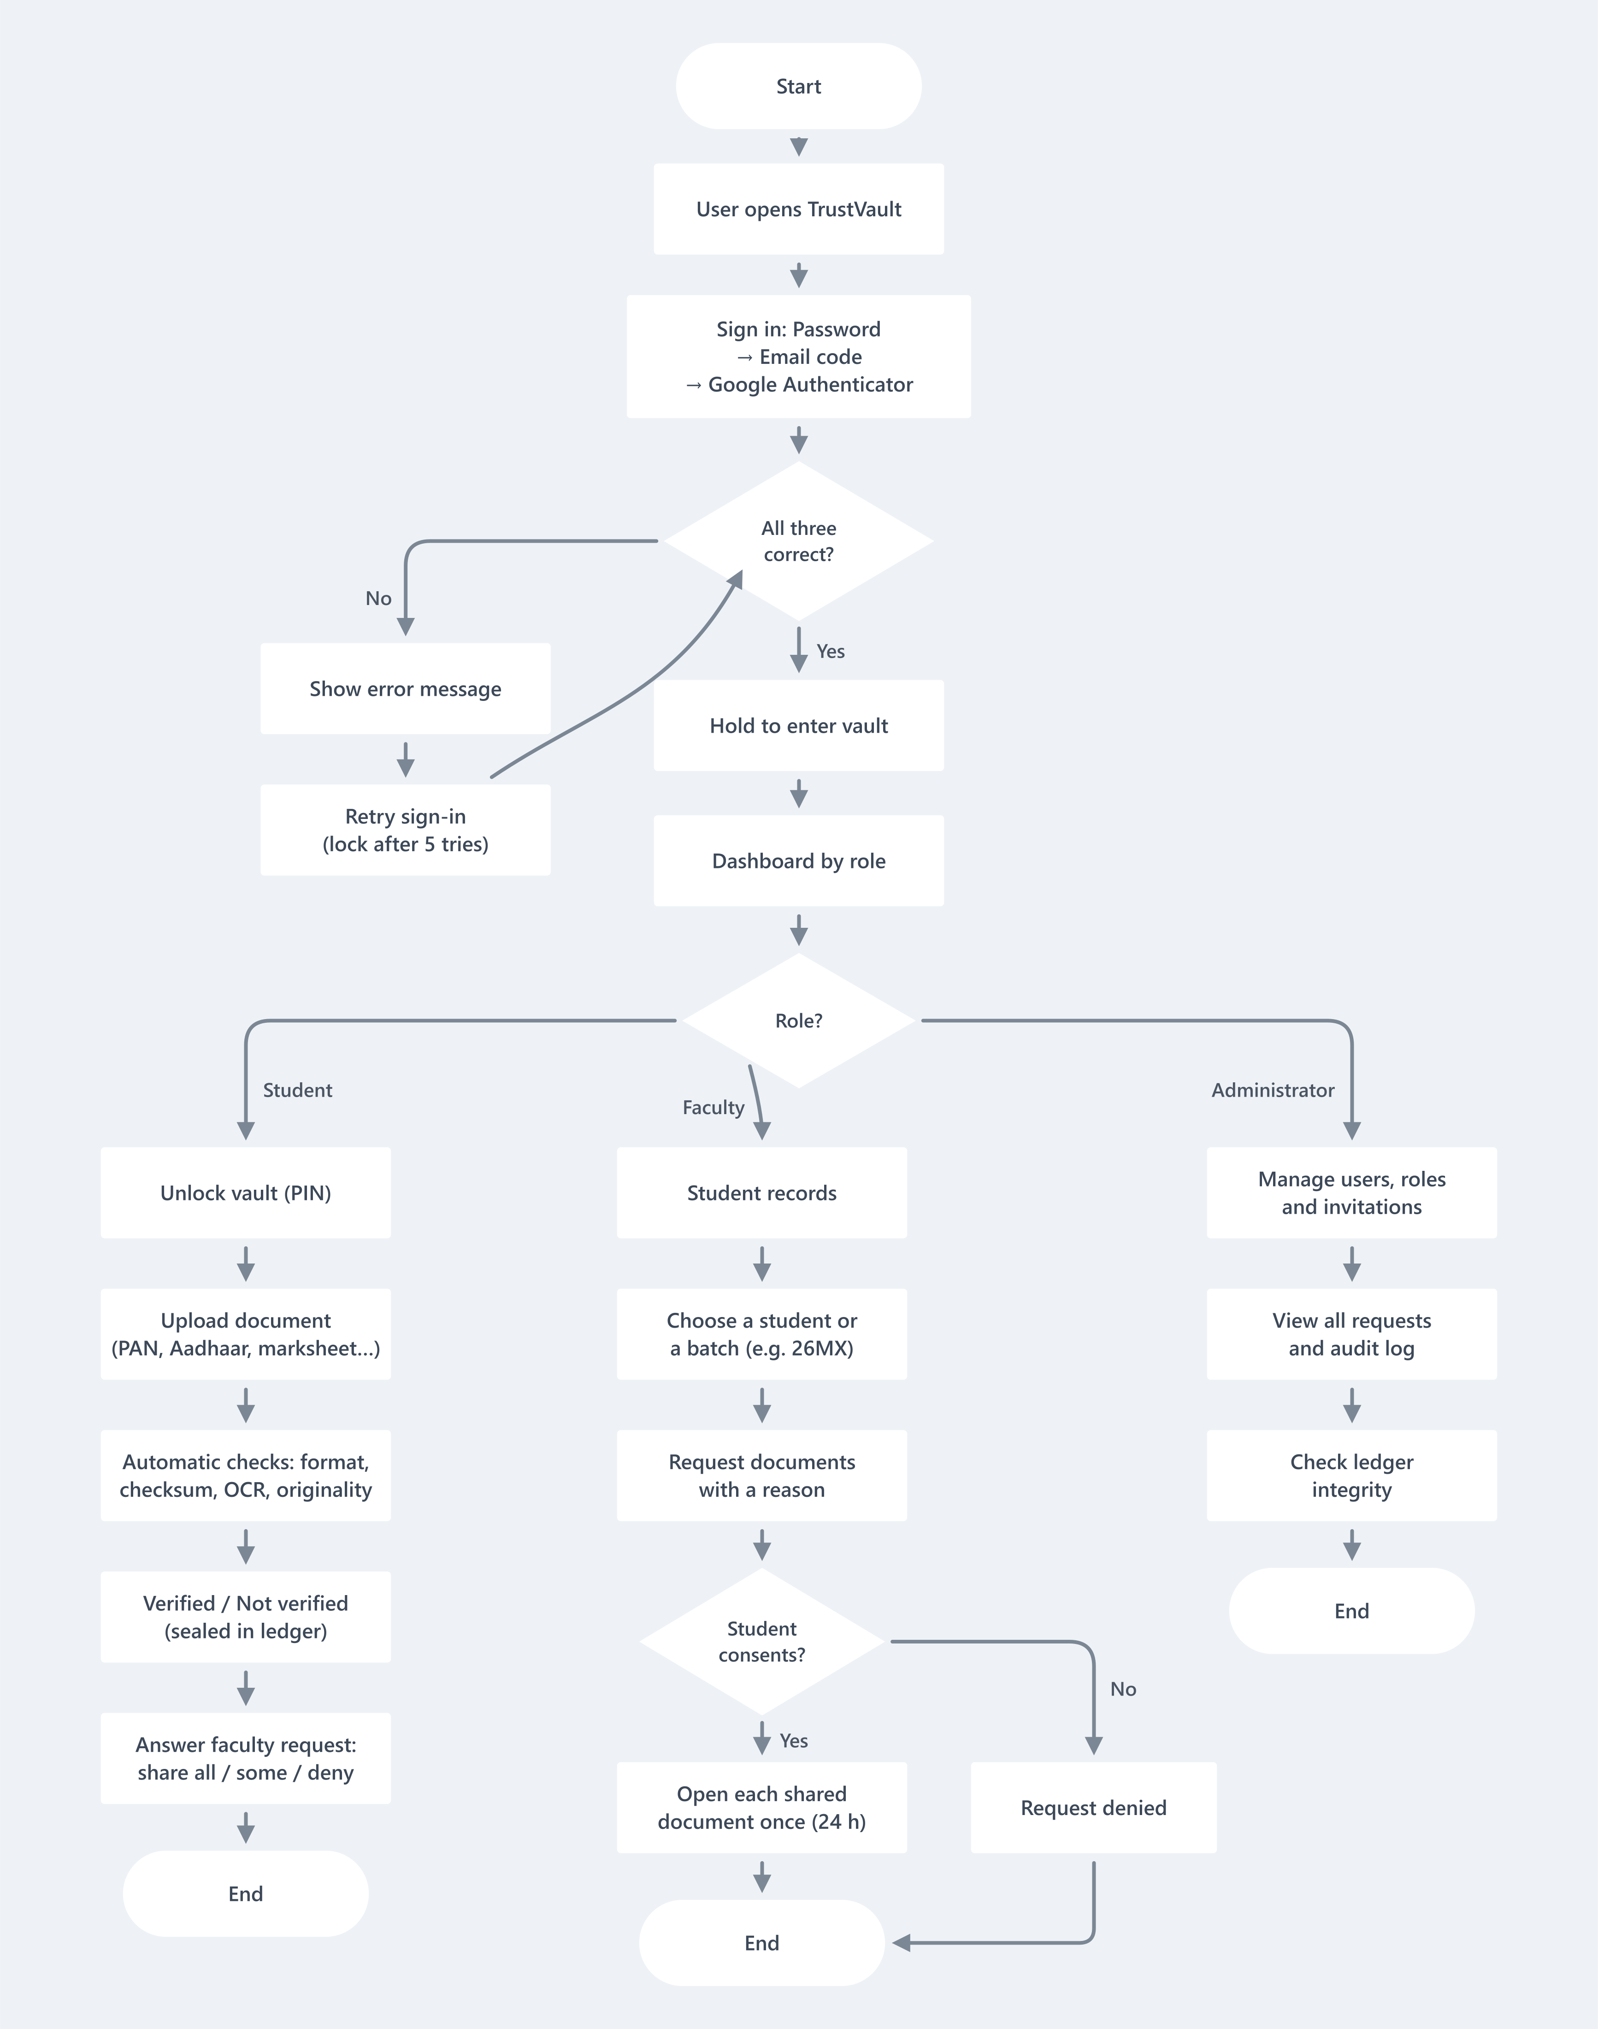
XII. Database Schema of the application (if any):
Users Collection
Field | Type | Description
_id | ObjectId (PK) | Unique user identifier
name | String | Full name
email | String | Login credential (unique)
studentId | String | MX roll number (students)
passwordHash | String | bcrypt hash of the password
role | String | Student / Faculty / Administrator
totpSecret | String | Encrypted Authenticator secret
vaultPinHash | String | Hash of the vault PIN
Documents Collection
Field | Type | Description
_id | ObjectId (PK) | Unique document ID
owner | ObjectId (FK) | Student reference
type | String | PAN / Aadhaar / Licence / Marksheet / etc.
title | String | Document name
numberMasked | String | Masked number (XXXX XXXX 1234)
storedName | String | Encrypted file on disk
sha256 | String | File fingerprint
status | String | Pending / Verified / Not verified / Stored
autoCheck | Object | Score and result of each check
createdAt | Date | Upload time
Access Requests Collection
Field | Type | Description
_id | ObjectId (PK) | Unique request ID
verifier | ObjectId (FK) | Faculty reference
student | ObjectId (FK) | Student reference
reason | String | Purpose of the request
types | Array | Document types asked for
granted | Array | Types the student shared
opened | Array | Documents already opened (once each)
status | String | Pending / Approved / Denied / Revoked / Used
expiresAt | Date | End of the 24-hour access
Ledger (Blocks) Collection
Field | Type | Description
index | Number (PK) | Block number
action | String | Upload / Verified / Not verified
docId | ObjectId (FK) | Document reference
fileHash | String | SHA-256 of the file
prevHash | String | Hash of the previous block
hash | String | Hash of this block
at | Date | Time recorded
Audit Log Collection
Field | Type | Description
_id | ObjectId (PK) | Unique entry ID
user | ObjectId (FK) | Who performed the action
subject | ObjectId (FK) | Whose data it was
action | String | Event name
createdAt | Date | Event time
XIII: Timeline of Activities planned/completed
Phase | Activity | Status
Week 1 | Requirement Analysis | Completed
Week 2 | UI/UX Design | Completed
Week 3 | Database Design | Completed
Week 4 | Frontend Development | Completed
Week 5 | Backend Development | Completed
Week 6 | Integration & Testing | Completed
Week 7 | Bug Fixing & Optimization | Completed
Week 8 | Documentation & Final Review | In progress

Signature of the students  Name 1: KIRUBHAKARAN K (26MX325)  Name 2: POOJA M (26MX337)  Name 3: SRINITHISH J K (26MX347) | Signature of the Guide  Name: DR. ILAYARAJA N

